**Name: __________________________________**

**Year 11 Human Biology**

**Skin Bacteria Investigation Validation /37**

**Experiment #1**

Professor Anthony Hilton from Aston University has recently released findings supporting the 5 second rule – that food picked up less than 5 seconds after being dropped on the floor is less likely to pick up bacteria.

Explain two features of bacteria 2

Some students decided to verify Professor Hilton’s findings. They chose two different surfaces and 3 different types of food to drop. They also had 2 controls. One where the food was not dropped on the floor at all and another where it was left on the floor for a whole minute.

After each piece of food was dropped it was rubbed on an agar plate and left in the incubator for 5 days. Three samples of each type of food were tested on each surface.

The number of bacterial colonies was counted after 5 days and an average worked out to produce the results below:

[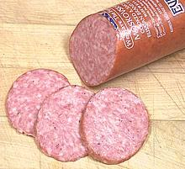](http://www.google.com.au/url?sa=i&rct=j&q=polony+slice&source=images&cd=&cad=rja&uact=8&docid=UpmtDEyiIQGTNM&tbnid=_Z8m7EqOKB644M:&ved=0CAUQjRw&url=http://www.clovegarden.com/ingred/sausage.html&ei=0v6wU7GGAYfkkgXf6YDoCA&psig=AFQjCNGdmsa1bC4AD8-dBRHl7ZzNZtEz-g&ust=1404194817655050)[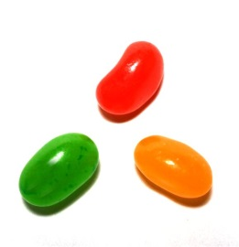](http://www.google.com.au/url?sa=i&rct=j&q=jelly+beans&source=images&cd=&cad=rja&uact=8&docid=rbcMK72jTfdQyM&tbnid=waR4BY7YCd4_pM:&ved=0CAUQjRw&url=http://vr-zone.com/articles/buy-the-first-android-jelly-bean-smartphone/16371.html?TB_iframe%3Dtrue%26height%3D650%26width%3D850&ei=isqfU5eDBYr88QXOs4K4Cw&psig=AFQjCNGG_X_ihi6y5qD9p5pbHdsu6czL5A&ust=1403067393648115)

[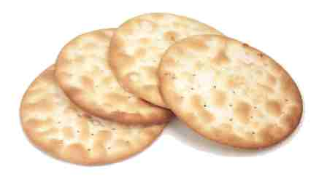](http://www.google.com.au/url?sa=i&rct=j&q=crackers&source=images&cd=&docid=aeRHRDijI2o0aM&tbnid=eDj-s6mztEiacM:&ved=0CAUQjRw&url=http://www.foodsubs.com/Crackers.html&ei=A8ufU_qbBYGskAXzr4GACQ&psig=AFQjCNEDkGYwtGW0YbMxkuaqbhZ8Wjz-cw&ust=1403067447858043)Jelly Beans Polony Crackers

Why did they test more than one type of food and one type of surface? 2

What hypothesis may the scientists have used? 2

What is the independent variable? 1

What is the dependent variable? 1

What variables would they have had to control? 3

What conclusion can you form based on these results? 3

There are pathogens on all food that we eat. List 4 different types of pathogens 2

* .
* .
* .
* .

Describe two non-specific defences against pathogens that we may ingest (eat). 4

**Experiment #2**

Students wanted to compare the bacteria left on hands after using an anti-bacterial soap with hands washed in plain water. They did this by placing their hands on an agar plate then incubating it for 5 days.

At what temperature should they have incubated the plates at and why? 2

They tested hand not washed, hand washed in water and hand washed with the anti-bacterial soap. Why did they test unwashed hands and hands washed in plain water? 2

What is the independent variable? 1

What is the dependent variable? 1

What hypothesis may they have been testing? 2

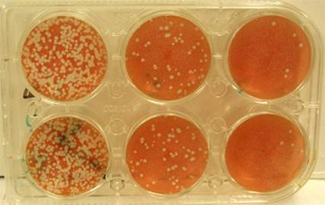

**C**

**B**

**A**

The students tested each situation twice and obtained the above results. Which pairs of results would you expect to obtain from each situation? 1

*Unwashed, washed in water and washed in antibacterial soap.*

A.____________________________________________

B._____________________________________________

C._____________________________________________

Explain your choice 2

Most bacteria are harmless. Describe two examples of bacteria that are **not** harmful to humans. 2

Some bacteria cause disease. Name 2 diseases caused by bacteria in humans. 1

* .
* .

List three ways in which we can help our external defences prevent the bacteria mentioned above invading our body 3

Label the following bacterial cell 2

[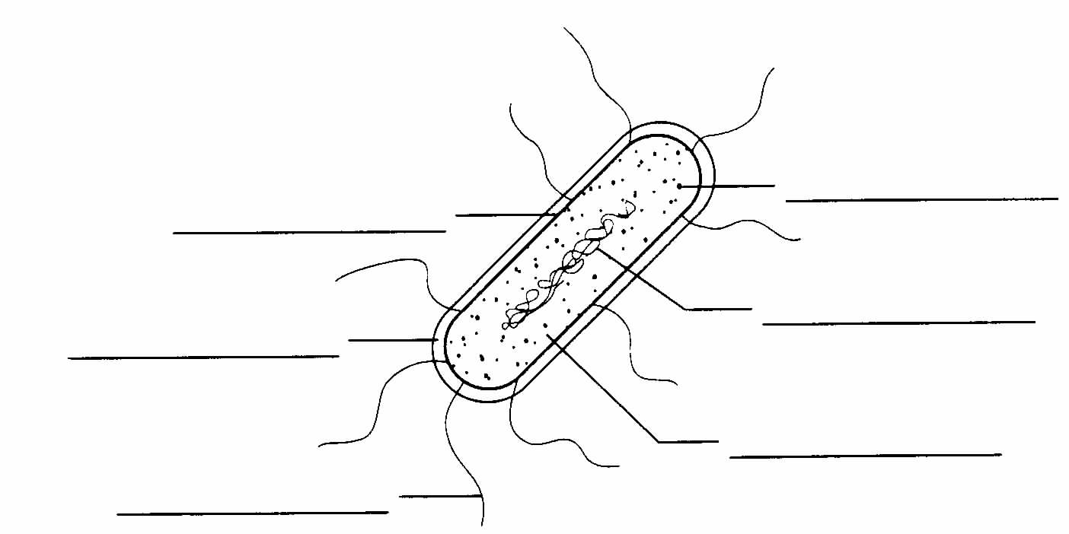](http://www.google.com.au/url?sa=i&rct=j&q=&esrc=s&frm=1&source=images&cd=&cad=rja&docid=EOU9_x4lxI_2sM&tbnid=q70lwV7dYtSzdM:&ved=0CAUQjRw&url=http://ohs-bio.www1.50megs.com/ch17/Chapter%2017%20Worksheet-2.htm&ei=lFpvUaPSIoehkAWa4IHABA&bvm=bv.45368065,d.dGI&psig=AFQjCNGCfQQCYpvRcYNVd7TMc_uqVJUHuA&ust=1366338568969798)

**Name: SOLUTIONS**

**Year 11 Human Biology**

**Skin Bacteria Investigation Validation /37**

**Experiment #1**

Professor Anthony Hilton from Aston University has recently released findings supporting the 5 second rule – that is that food picked up less than 5 seconds after being dropped on the floor is less likely to pick up bacteria.

Explain two features of bacteria 2

Slime Layer any 2 explained

Flagella for movement

Single Cell

DNA – no nuclear membrane

Plasmids can be exchanged during reproduction

Some students decided to verify Professor Hiltons findings. They chose two different surfaces and 3 different types of food to drop. They also had 2 controls. One where the food was not dropped on the floor at all and another where it was left on the floor for a whole minute.

After each piece of food was dropped it was rubbed on an agar plate and left in the incubator for 5 days. Three samples of each type of food were tested on each surface.

The number of bacterial colonies was counted after 5 days and an average worked out to produce the results below:

Why did they test more than one type of food and one type of surface? 2

To ensure reliability of results any reasonable answer

Fair test

What hypothesis may the scientists have used? 2

Food dropped on the floor for less than 5 seconds will contain more bacteria than food not dropped on the floor

Or a reasonable hypothesis that matches the variables listed below

What is the independent variable? 1

Dropped on the floor for less than 5 seconds or not dropped on the floor

What is the dependent variable? 1

Number of bacterial colonies

What variables would they have had to control? 3

Size of food samples

Length of time on floor

Height from which it was dropped any 3 reasonable answers

What conclusion can you form based on these results? 3

Food that is dropped on the floor for less than five seconds contains more bacteria than food not dropped on the floor

All foods

All surfaces

There are pathogens on all food that we eat. List 4 different types of pathogens 2

* .bacteria
* .viruses
* .fungi
* .animal parasites

Describe two non-specific defences against pathogens that we may ingest (eat). 4

Vomiting explained 1 mark for each listed (up to 2)

Diarohea explained 1 mark for each explanation

Acid in stomach explained

**Experiment #2**

Students wanted to compare the bacteria left on hands after using an anti-bacterial soap. They did this by placing their hands on an agar plate and incubating it for 5 days.

At what temperature should they have incubated the plates at and why? 2

1 mark 36.7 degrees or similar

1 mark body temperature to simulate being on the body

They tested hand not washed, hand washed in water and hand washed with the anti-bacterial soap. Why did they test unwashed hands and hands washed in plain water? 2

1 mark Control

1 mark Explained

What is the independent variable? 1

Washing of hands – substance hands are washed in

What is the dependent variable? 1

Number of bacterial colonies

What hypothesis may they have been testing? 2

Washing hands with anti-bacterial soap reduces the amount of bacteria present



**C**

**B**

**A**

The students tested each situation twice and obtained the above results. Which pairs of results would you expect to obtain from each situation? 1

*Unwashed, washed in water and washed in antibacterial soap.*

AUnwashed

B.washed in plain water

C._washed with antibacterial soap

Explain your choice 2

No washing – most bacteria

Washing in water removes some

Antibacterial soap kills most

Most bacteria are harmless. Describe two examples of bacteria that are not harmful to humans.2

Lactobacilli in Yoghurt

Bacteria in food example

Intestinal Bacteria any 2 examples described

Some bacteria cause disease. Name 2 diseases caused by bacteria in humans. 1

* .Any two ½ mark each

List three ways in which we can help our external defences prevent the bacteria mentioned above invading our body 3

Label the following bacterial cell 2

[](http://www.google.com.au/url?sa=i&rct=j&q=&esrc=s&frm=1&source=images&cd=&cad=rja&docid=EOU9_x4lxI_2sM&tbnid=q70lwV7dYtSzdM:&ved=0CAUQjRw&url=http://ohs-bio.www1.50megs.com/ch17/Chapter%2017%20Worksheet-2.htm&ei=lFpvUaPSIoehkAWa4IHABA&bvm=bv.45368065,d.dGI&psig=AFQjCNGCfQQCYpvRcYNVd7TMc_uqVJUHuA&ust=1366338568969798)

Cell Membrane Ribosomes

Capsule DNA

Flagella Cytoplasm